**Master Functional Document**

|  |  |
| --- | --- |
| **Application** | NGERP - Centra |
| **Service Bundle** | Master Management |
| **Service Request** | Business Partner |

**Description:**

In Compiere (NGERP – CENTRA), the Business Partner window defines all entities you interact with-customers, vendors, and employees. It stores critical data used to generate transactions like orders, invoices, and shipments. Vendors must be defined before adding products, and customers must be defined before creating orders.

**Workflow Process:**

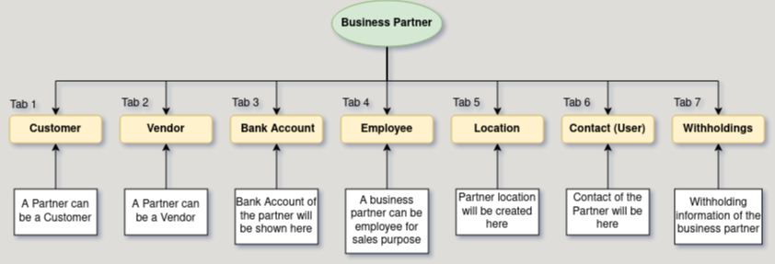

**Business Rules:**

* **It** is visible in both HQ and ROW**.**
* Creation is possible in both HQ and ROW.
* Each business partner must have a unique identifier.
* Basic details must be entered before transactions.
* Define vendors before adding products.
* Define customers before creating orders.
* Any updates must be reflected across all transactions.